Name:____________

Egyptian Gods and Goddess: Using the website www.egyptianmyths.net/section-deities.htm), describe the following:

- Ra:

- Isis:

- Anubis:
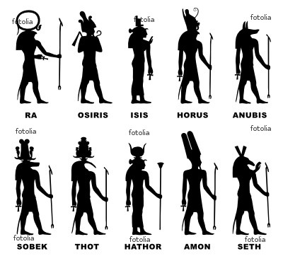

- Imhotep

- Osiris

6. Horus

- Thoth

- Amon

- Seth

- Nefertem

Ancient Egypt by Joanne O’Brien www.egyptianmyths.net/aegypt.htm

- How long did the civilization of Ancient Egypt flourish?

- How was Egypt divided? Describe the “bitter struggle”

- What are the most important periods of Egyptian history? From whose rule to when

- When did Egypt suffer from a series of foreign invasions?

- Describe the life in Ancient Egypt (along Nile and beyond)

- What did people celebrate at the time of the yearly flood? Describe this celebration.

- In the New Kingdom, what did the power of the priesthood threaten?

- What did the Egyptians put a great emphasis on? What was required before acquiring a job?

- What are hieroglyphs?

- Who is the pharaoh believed to be? Who is the most important and oldest of the gods?

- What was essential to Egyptian life?

Egyptian Activities:
1. Egyptian Mummification: read the information at http://www.ancientegypt.co.uk/mummies/index.html On a separate sheet of paper, write a page summary and commentary over the material.

2. Hieroglyphs: Using the alphabet spell your name.
www.greatscott.com/hiero/hiero_alpha.html

________________________________________________________________

- Resources>Pyramid--The Inside Story> Explore the Pyramids> select either Menkaure, Khafre, The Sphinx or Khufu to read and research. Comment on the blog on my website about your findings.
- The Mummy’s Curse: www.touregypt.net/featurestories/curse.htm
  - What artifacts or engravings might have led people to develop the curse story?

  - What events contributed to the rumor of a curse?

  - Have there been any scientific explanations for the events that contributed to the curse rumor? If so, what are they?

  - Classify the possible explanations for the "curse" into the following categories:

    - scientific explanations, like the speculation that exposure to ancient toxins in the tomb was responsible for Lord Carnarvon's death

    - cultural explanations, like the fact that belief in the afterlife was strong in ancient Egypt, which would make people more likely to believe that supernatural beings might protect the tomb

5. Mythology in Art: www.artsmia.org/world-myths/
Directions: website>Art by Theme>Heroes>read and answer discussion questions

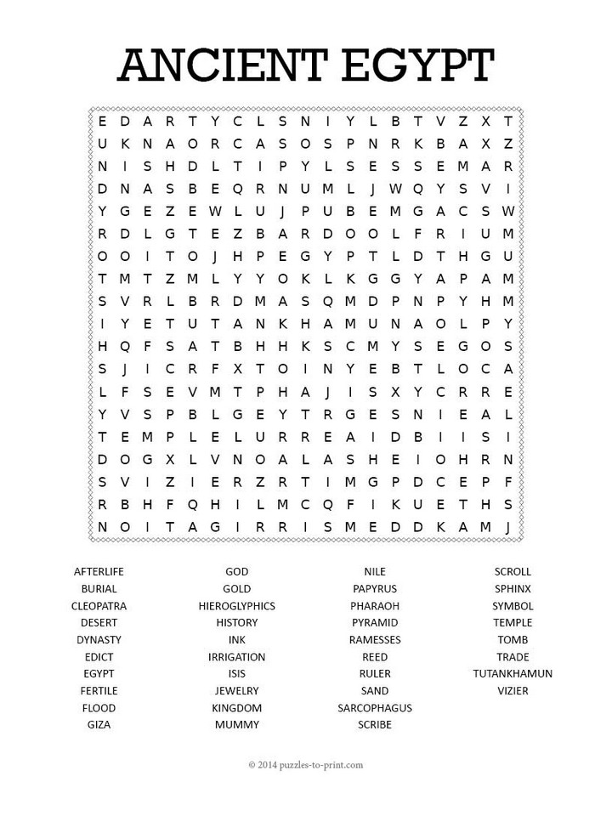
The Egyptian Farmer

In ancient Egyptian society, as well as today, farming was very important. The farmer had to provide food for tradesman, leaders, and slaves. He worked very hard along the fertile Nile River Valley. This valley provided fine soil for raising grain, vegetables, and fruits.
The farmer had to follow a time schedule if he was to be successful. In July, when the water level of the Nile began to rise, the farmers had little to do. If he planted anything, it would simply be flooded. Therefore, he spent this time working for the Pharaoh on one of his building projects.
The water-level would go down in November. The farmers had to plow the soil very quickly while it was moist. After the fields were plowed and the furrows hoed, they planted the seeds. They then irrigated and checked the area for weeds while the crops grew.
The tax officials would visit the farms at this time. The amount of taxes to be paid was determined by measuring his crop. This was done by stretching a rope around the area where the crops were growing. By the end of March, the farmers were using sickles to reap the grain. The women would then toss the grain into the wind to remove the husk. Now the grain was ready to be stored for the flood season.
Briefly summarize:

The Life of The Rich
Winer, Bart. Life in the Ancient World

Beyond the market or bazaar, in a separate part of town, rose the high walls that screened the houses of the rich. These homes, with mud-brick walls, wooden pillars, and palm-trunk rafters, were usually built around a courtyard. The windows were high, the doors small, to keep out sun and let in air. Mats that could be rolled up like shades covered the windows. There were rugs on the floor and bright carpets on the walls. Pillars were built in the shape of trees, with the column painted reddish brown and the leafy top or capitol, bright green. Like the sky, the ceiling was blue. Included were workrooms and servants' quarters and the homes sometimes had as many as seventy rooms.
The rich man in his house slept on a wood-frame bed made of interlaced cords. with folded sheets fir a mattress and with a wooden headrest. Under his bed was a chamberpot.
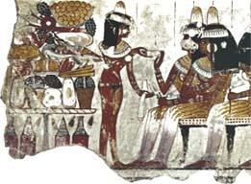
The wealthy Egyptian loved to give a good "beer house", as he called a dinner party. In early times, men squatted at mealtime on rugs and cushions. Servants placed a small stand before every two persons and served the food in bowls and the beer in jugs. In later times, there were tables and chairs, even chairs that could be folded up and put away in the chests and baskets that served as cupboards. A good host decorated everything with flowers - the table, the beer jugs, and the guests. Servants placed cones of perfumed ointment on the heads of the guests. These looked like large ice cream cones and, like ice cream, melted. They dripped over wigs and clothes, staining everything yellow, but they added a delightful scent to the air. In the tomb painting shown to the above right, fashionable ladies recieve a dish of refreshments from a slave girl at a party. Note the "cones" of perfume on their wigs. Musicians played during the meal. The guests were served many courses and several beers and wines and the party was considered a great success if most of the guests ended up drunk or sick.

Wealthy Egyptians built beautiful. spacious homes of brick and wood. They draped brightly colored hangings over latticed windows. Luxurious furnishings, such as rugs, ebony chests, and vessels of copper and gold decorated the homes. Gardens and orchards surrounded almost all the houses.
They ate beef, veal, antelope and gazelle meat, fruits, honeyed sweetmeats, and several kinds of bread and cakes. In the tomb painting seen to the left, workers tread grapes for a noble's estate. Egyptian wines were labeled with date, vineyard and variety to benefit the tax assessors, not connoisseurs.
Persons who could afford them wore wide, round collars of jewels or beads, They decorated their wrists and upper arms with beautiful rings and gay bracelets. Both for beauty and protection from the heat, wealthy Egyptians wore long. heavy black wigs of sheep's wool or human hair. Sometimes they wore striped or embroidered headdresses to signify the wearer's social standing.
Summarize key points:

Write the importance mythology would have been to both the wealthy and the farmers.

The Funerary Texts
Pyramid Texts

The Pyramid Texts are the earliest Egyptian funerary texts. They consist of approximately eight hundred spells or "utterances" which were carved on the walls and burial chambers of nine pyramids of the late Old Kingdom. The earliest surviving Pyramid Texts are found on the Fifth Dynasty pyramid of King Unas (image at left is of his burial chamber) at Saqqara. The first Pyramid Texts to be discovered were found in the pyramid of King Pepy II. None of the pyramids contains all of the utterances. The utterances evidently were not written in any particular order. The pyramid with the most belonged to King Pepy II. It held 675.
The Pyramid Texts were first discovered in 1880 by Gaston Maspero. Two years later, Maspero began the first translation of the texts. At first, scholars believed that the texts may have pre-dated the pyramids themselves by hundreds or even, thousands, of years. Now, many scholars believe that the texts are contempory to the pyramids.
In the Old Kingdom, only the pharaoh had the ability to live on beyond death. As a living god on earth, he was the connection between the divine and the mortal. The pharaoh's duty on earth was to uphold Ma'at, the principle of order and truth. At death, the Pyramid Texts stated that the pharaoh was to become the sun or the new Osiris. However, the journey of this transformation was perilous. The Pyramid Texts were a collection of spells, prayers, descriptions and instructions designed to allow the king a safe journey to the Afterlife.
The texts repeatedly refer to the cult of the sun-god. This implies that they were originally written by the priests of Heliopolis. Several of the spells are written in an archaic dialect or refer to features of the funerary cult that were no longer current at the time the pyramids were built. This indicates that at least some of the Pyramid Texts can be dated to Pre-Dynastic times.
The texts may provide clues to the thinking behind the development of the pyramid itself. The ultimate destination of the pharaoh after death was the sky. The pyramid, in its original stepped form, provided him with a staircase to the sky. In its later true pyramid form, the pyramid symbolized the sun's rays, which were another means by which the king could ascend to the heavens.
Coffin Texts
During the Old Kingdom, the afterlife was only available to the king. However, after the Old Kingdom collapsed, the people became more self-reliant. With this new development came a process by which the common people received the promise of the afterlife. Egyptologists refer to this evolution of thought as the "democratization of the afterlife."
Now that the common people had a chance at life after death, they meant to cash in on it. Therefore, they had spells carved on their coffins or sarcophagi that contained instructions and protections for living on after their death. These spells were descended from the Pyramid Texts and formed the basis of the Book of the Dead. Over 1,000 spells have been recorded. Collectively, these spells are known as the "Coffins Texts."
Like the earlier Pyramid Texts, the Coffin Texts indicate that there was more than one possible destination for the deceased. They might join the sun-god Re in the sky, or pass into the underworld of Osiris. The earlier texts subscribe to the first version, while the latter were more likely to indicate the second. This changing thought pattern led into the funerary beliefs of the New Kingdom, which Osiris dominated.
Book of the Dead (Book of Going Forth by Day)
The Book of the Dead is a New Kingdom collection of texts composed primarily from earlier funerary works such as the Pyramid and Coffin Texts. It was usually written on papyrus, however many individual chapters of the book have been found on tomb walls, scarabs, statuettes and on at least one royal mortuary temple (Rameses III).
Manuscripts of the Book of the Dead were customized with the name of each deceased person prefixed by "Osiris" (i.e. Osiris-Rameses). The books also included the deceased person's job title and family relations. Some books were written ahead of time with the spot for the deceased's name left blank. The name was filled in later when the book was purchased.
The cost of the books probably varied widely, given the range of quality found in still existing books. The book was made affordable for almost all Egyptians when abbreviated versions became available the Late Period.
The Book of the Dead is renowned in large part due to the vignettes, or small paintings, that accompany the text. Quite famous is the vignette of the "Judgement of the Dead" from Chapter 125. Some of the vignettes originally appeared in the Coffin Texts. The number of vignettes in a copy did not follow any standard. Some versions had none, while others had a drawing for almost every chapter.
It seems that in at least some cases, the layout of the book and the painting of the vignettes was done prior to the filling in of the writings. This resulted in the mislocation of the vignettes. Also, in some cases the text suffered omissions or abbreviations as the scribe ran out of space! The Book of the Dead was written in cursive hieroglyphics. The book was divided by "rubrics", or headings written in red ink. These divisions in the book are called "chapters" by modern Egyptologists.
The modern name of the Book of the Dead derives from the Arabic title, and simply refers to the fact that it usually accompanied mummies. The ancient name, "The Beginning of the Spells for Going Forth by Day" is found at the beginning of Chapter 1 (and Chapter 17). However, there is some debate concerning whether this title describes all of the book, or was meant only for that chapter.
A few chapters of the book were used widely outside of the papyrus. Chapter 30, the heart spell, was carved on the amulets placed in a mummy's body prior to wrapping it with linen. Also, chapter 6 was carved onto the shawabtis, small mummiform statuettes placed in tombs. The chapter was meant to allow the shawabtis to spring to life and do any work needed by the deceased.
After reading about the three types of texts, define each and compare and contrast each text:

